2023 ISOMRM & BCRS
Aug. 31 – Sep. 3 2023, Taipei, Taiwan
LMP1 gene detection through polymerase chain reaction in microfluidic chip combined with nanoslit surface plasmon resonance sensor
Han-Yun Hsieh¹, Ray Chang², Yung-Yu Huang¹, Pei-Kuen Wei³, Horn-Jiunn Sheen¹, Yu-Jui Fan^{2,*}
(Underline the name of the presenting author. The corresponding author(s) should be marked with an asterisk in the author list.)

¹Institute of Applied Mechanics, National Taiwan University, Taipei, Taiwan
²School of Biomedical Engineering, Taipei Medical University, Taipei, Taiwan
³Research Center for Applied Sciences, Academia Sinica, Taipei, Taiwan
*E-mail ray.yj.fan@tmu.edu.tw

Abstract:
Epstein-Barr virus (EBV), a member of herpes virus family. EBV can establish distinct latency types (latency 0, I, II, III). Latent membrane protein 1 (LMP1) has been recognized as an oncoprotein. LMP1 was recognized at latency II and III in EBV, which can be used as a prognostic biomarker in nasopharyngeal carcinoma and Hodgkin disease (HD). Therefore, the detection of LMP1 DNA fragments is essential in achieving the early diagnosis of cancer [1].
For detection of specific fragments of DNA, Polymerase chain reaction (PCR) is a technique widely used to amplify the target DNA. Although microfluidic PCR has the advantage of accelerating the reaction, but it still needs to cooperate with other detection method to confirm the products after reaction. However, immunofluorescence analysis has the advantages of small size, rapid detection, but the cost is relatively high. Therefore, some research groups combined PCR with label-free biosensors [2]. Here, we developed a microfluidic PCR combined with SPR sensor that can integrate DNA replication and detection on the same platform. Compared to traditional PCR machine, microfluidic PCR significantly reduced the volume of reaction chamber, decrease the sample consumption. The device designed by our research group can amplify specific gene fragment at the front-end, and perform the detection at the back-end. It not only can accelerate the PCR reaction speed but also can detect target DNA under the low concentration. In this research, we used real specimens to detect LMP1 DNA in the nasopharyngeal carcinoma patients, the results indicated that LMP1 DNA can be detected under low concentration (10 pg/mL). Based on the above results, we believed that our microfluidic PCR device can detect small amount DNA and create a platform for early diagnosis of nasopharyngeal carcinoma and lymphoma in the future.
To fabricate the device of PCR microfluidic channel and the SPR chip (Figure 1). The microfluidic channel is engraved into an acrylic plate. Another acrylic piece is bonded via hot pressing to complete the microfluidic channel. For the fabrication of SPR chip, the nanoslit structures are imprinted on a polycarbonate (PC) film by hot-embossing nanoimprinting lithography. Then, the SPR chip was bond to the microfluidic channel with double-sided tape. Finally, the SPR surface was modified with LMP1 probe.

KEYWORDS: Epstein-Barr virus (EBV), polymerase chain reaction, surface plasmon resonance, microfluidics
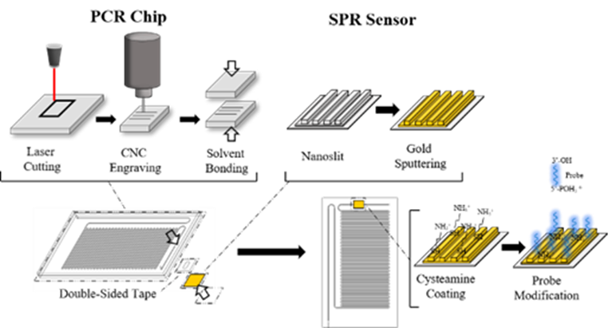

Graphic abstract (not a mandatory requirement)
[1] M. A. Epstein, B. G. Achong and Y. M. Barr: Virus particles in cultured lymphoblasts from burkitt's lymphoma. Lancet, 1(7335), 702-3 (1964)

[2] Y. P. Chen, W. N. Zhang, L. Chen, L. L. Tang, Y. P. Mao, W. F. Li, X. Liu, G. Q. Zhou, Y. Sun, T. B. Kang, M. S. Zeng, N. Liu and J. Ma: Effect of latent membrane protein 1 expression on overall survival in Epstein-Barr virus-associated cancers: a literature-based meta-analysis. Oncotarget, 6(30), 29311-29323 (2015)

